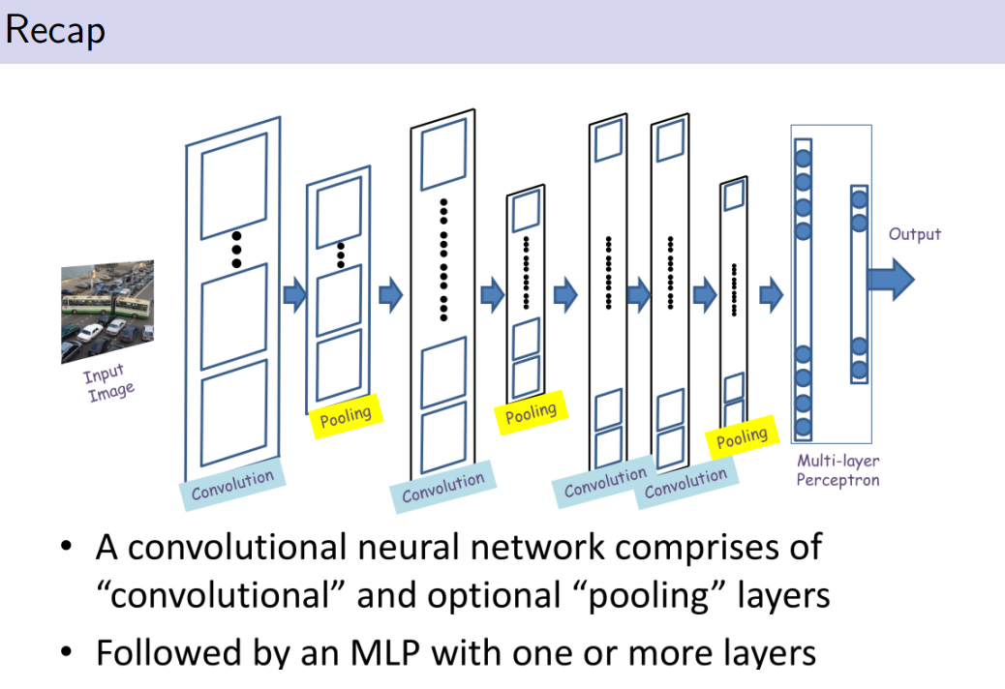

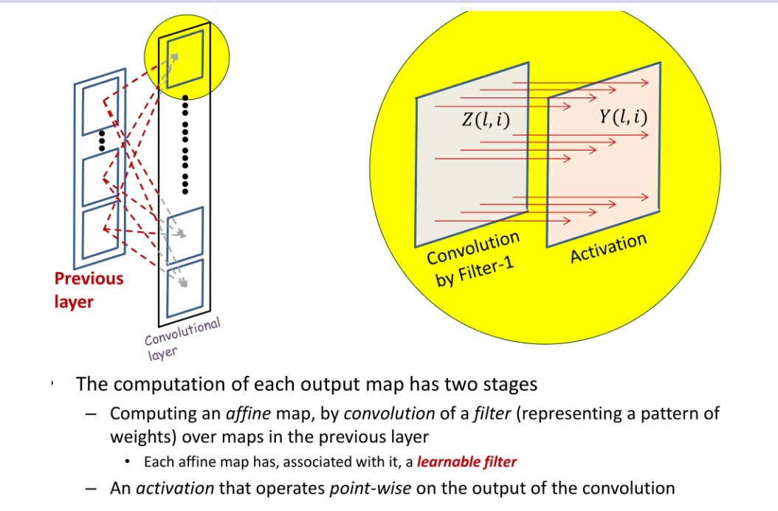
produce one output, on each point is applied the same nonlinear activation

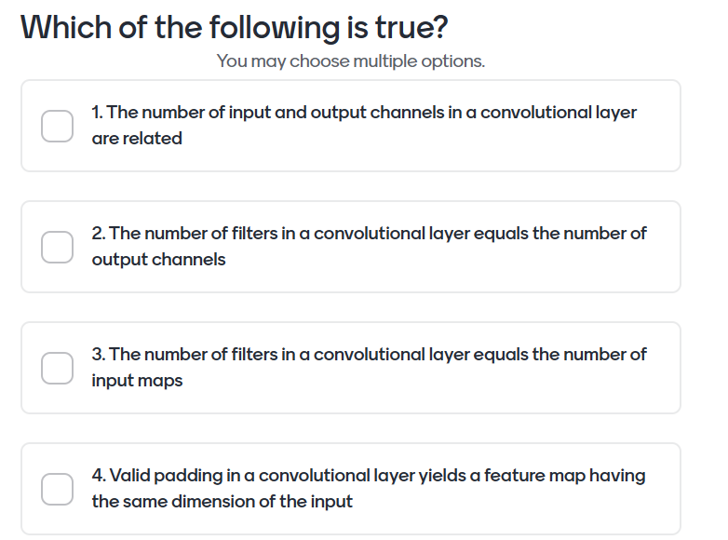

1. if I do not tell you the size of the filter I use. In pricople there can be any relations, depends on the fitler I use in the convulational layer. there is no relation, I can produce any output from any input, depends on the number of filters.

2. is true, no relation with the number of input

3. is false, the number of input maps is unrelated to the number of fitlers we use. the relations is with the number of output channels

4. need the SAME padding, valid you use the border, window not center in the borders, more focus on the center of the image,

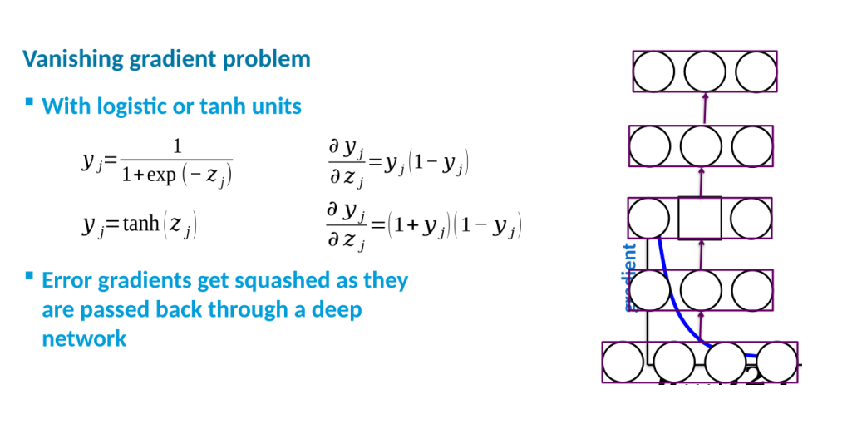
the number of layers (depth) is always helpful to increase the number of layers.

VANISHING GRADIENT PROBLEM
when I back propagate to compute the derivatives even in the initial layer I can get a multiplicative effect which has derivative

when you multuiplicate many terms at the end we back propagate to initial layer the dervite could be +compl

the layers could not be trained.

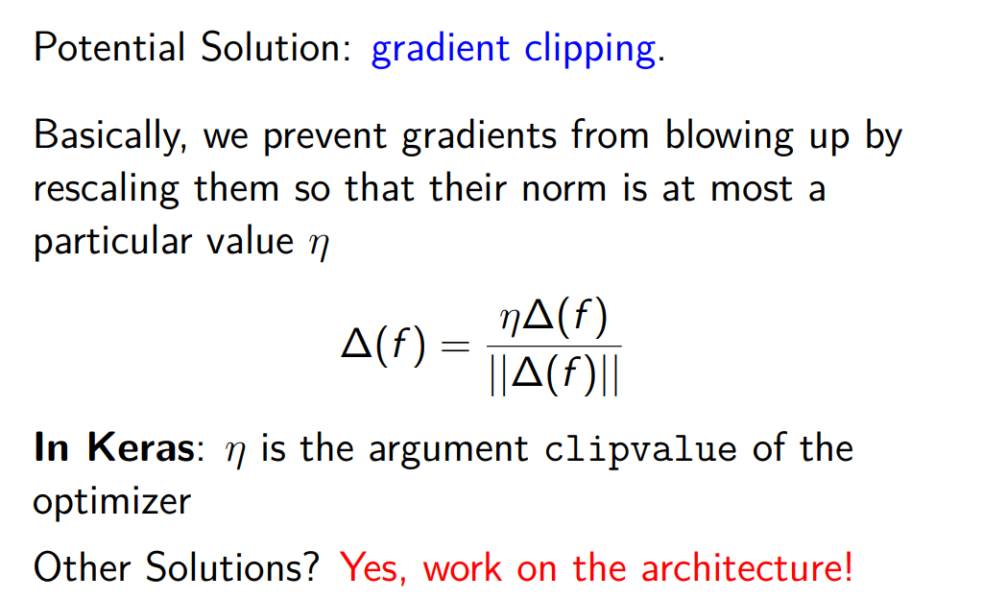

posing some questions and try to answer them

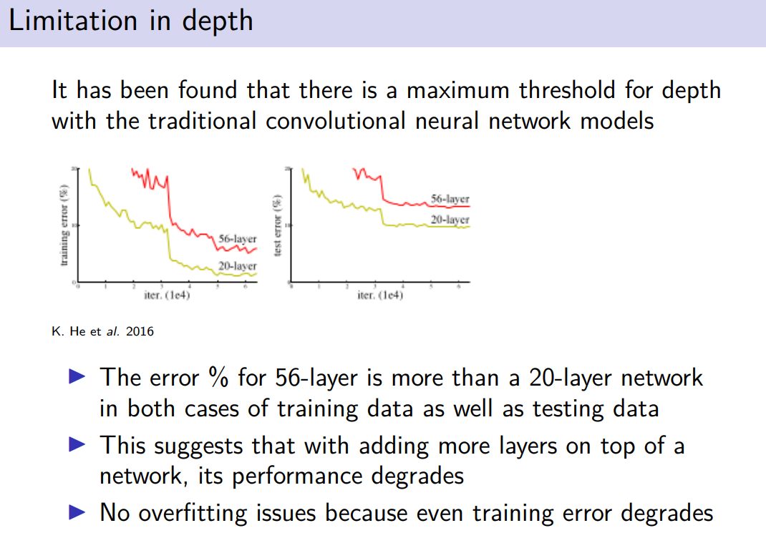

limitation in depth.

add more layers, checks what happens the more hidden layer. around 20 layers there is a threshold, when we increase they observed an unexpected phenomenon, the performance got worst.

on training and test the 20 layers is better

when we add more layers the learning is more complicated.
overfitting: too much training data, if the red on the training would be helow could be cast in overfitting, but is not the case. wven in the training it foes nto works

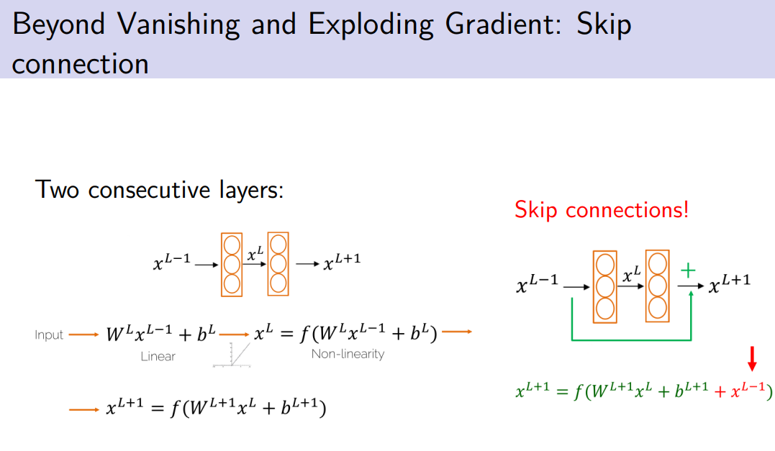
when introduce more layers makes difficult on training

if the layers we just have the identity (inout = output) the performance would have been the same, but stacking more layers is not even able to learn the identity.
suppose block with two hidden layers

the idea is to have a skip connection. Is a connotation that takes the input to the input of the layer after L+1, skip two hidden layer. (skipping one would be trivial because of the identity reason).

The last activation function now has another input. it has what it recivies + a red term X^{L-1}

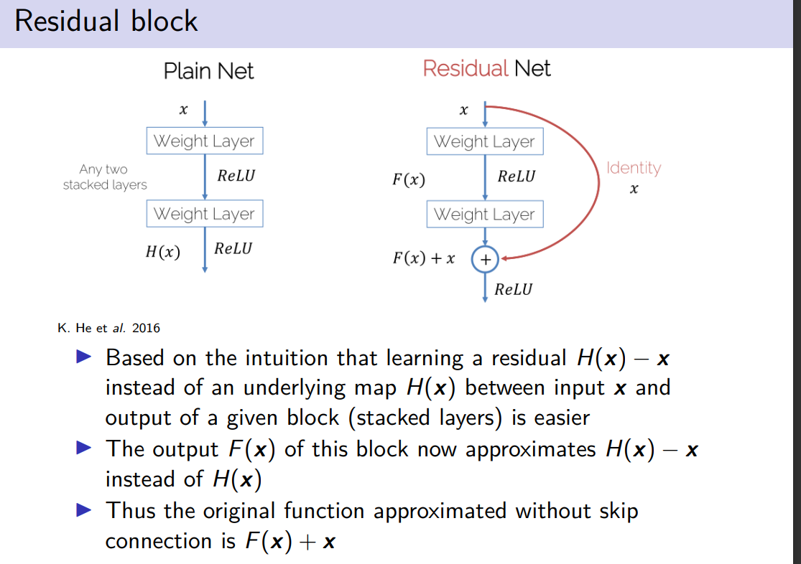
it is easier to learn the residual H(x) - x instead of learning H(x)

in principle if I have just identity layers (would preserve the performance, instead it degrades). Introducing the identity in some network would help problòably the network to train something more pwerroful,

skipping two layers: doing one is trivial, is not so powerful. It is naive, use at least two layers makes it potentially more powerful.

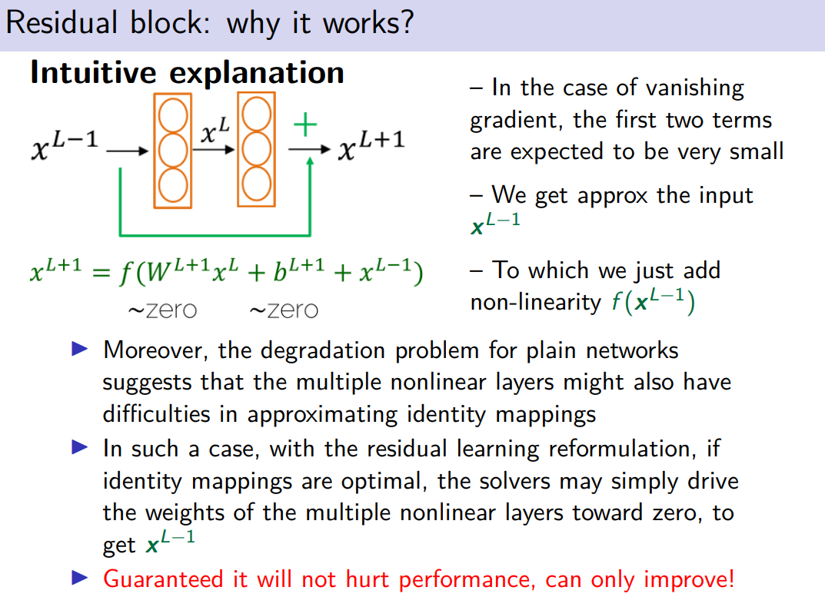

the first two terms are close to zero. we initial bias to 0 and grades close to 0, then we can expect this pehonkomenon

we output kist X^{L-1}

you are guarantee that the per9formance will not decrease, and it will be the same. If the lawyers in the worst case are the diendity they are the same, we get an piprmvement

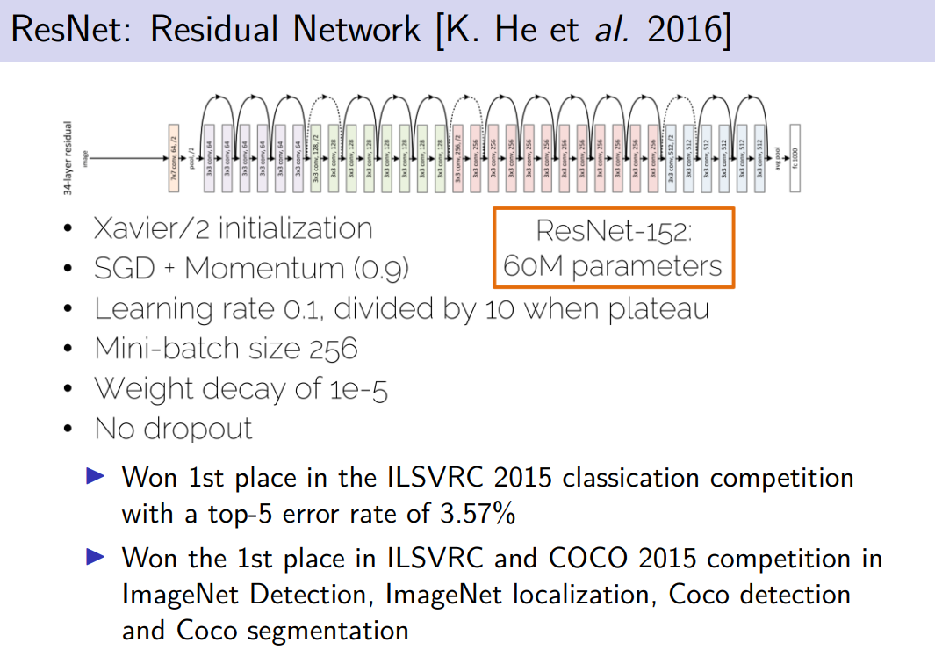
Xavier intiailization: weights such that that have same varancie, induce simlr behaviuiur of the neurons.

Stochastic gradient descent (SGD)

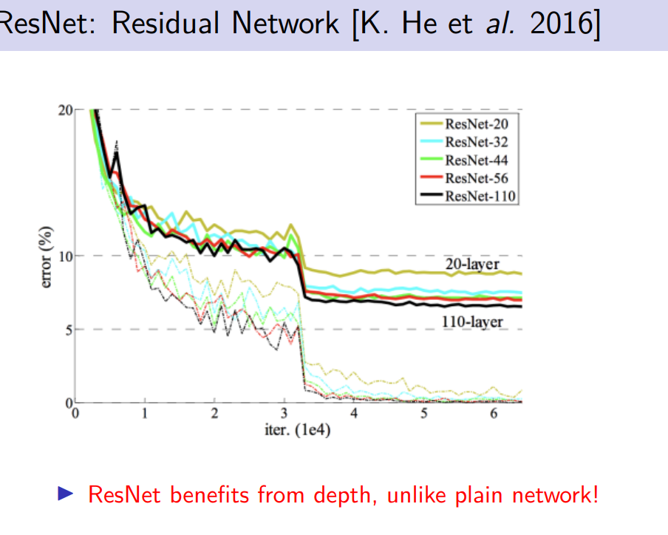
the performance improves

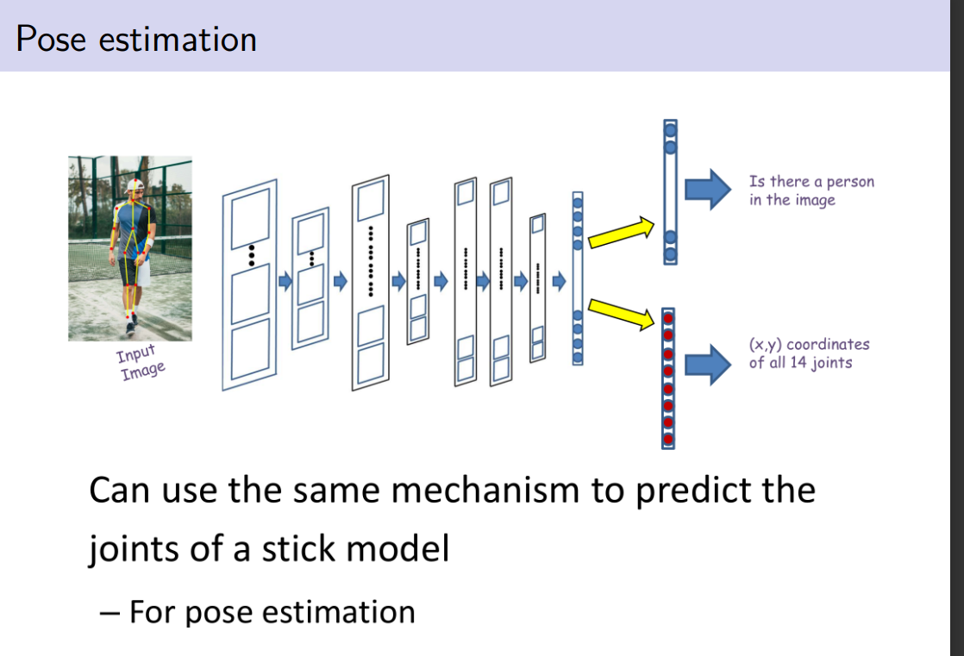
suppose we have an image, we want to mnow if there is a person and the 14 joints of the person, to see the pose

use the convultaiton networ, 2 oupits
- yes there is a person or not
- 14 couples of the joints of the person

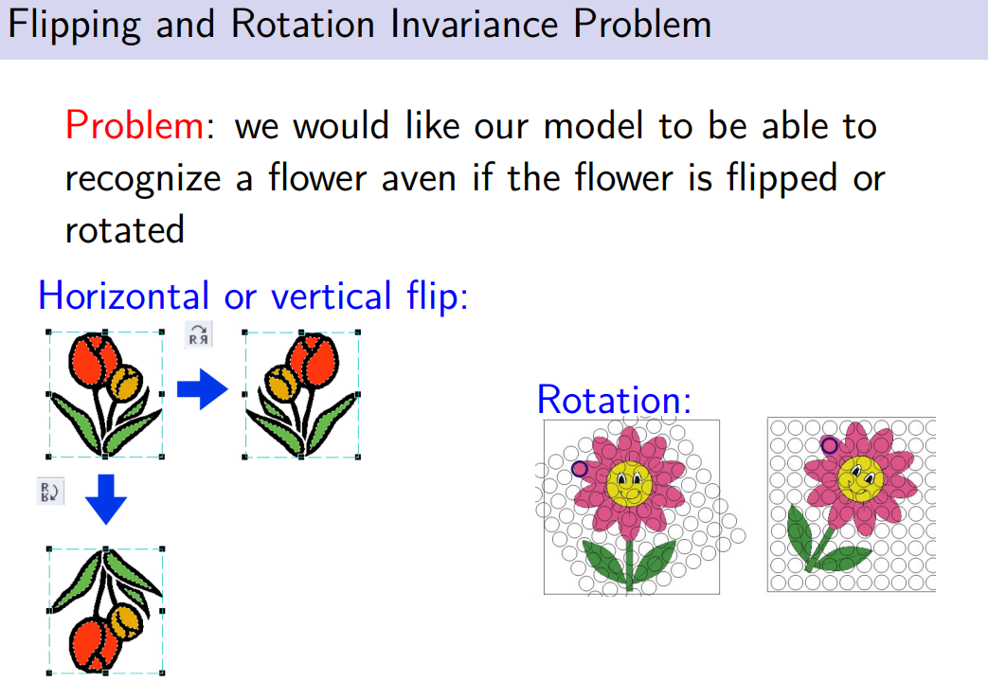

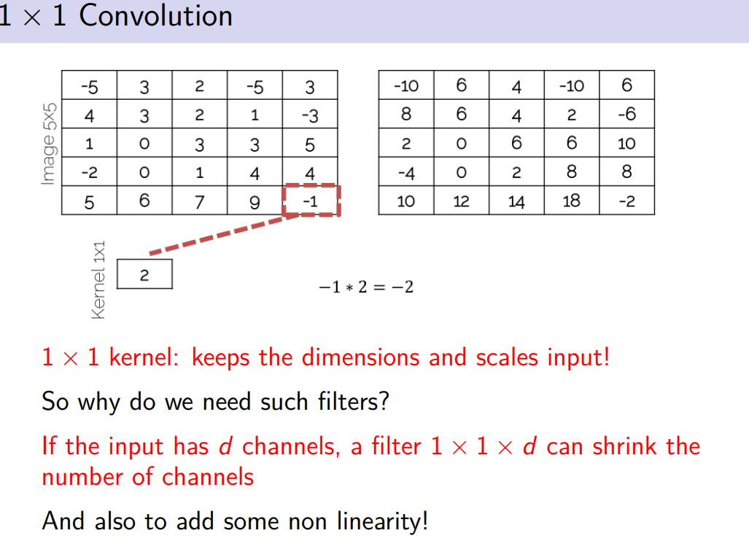
use for reduce the number of channels

suppose we have d channels

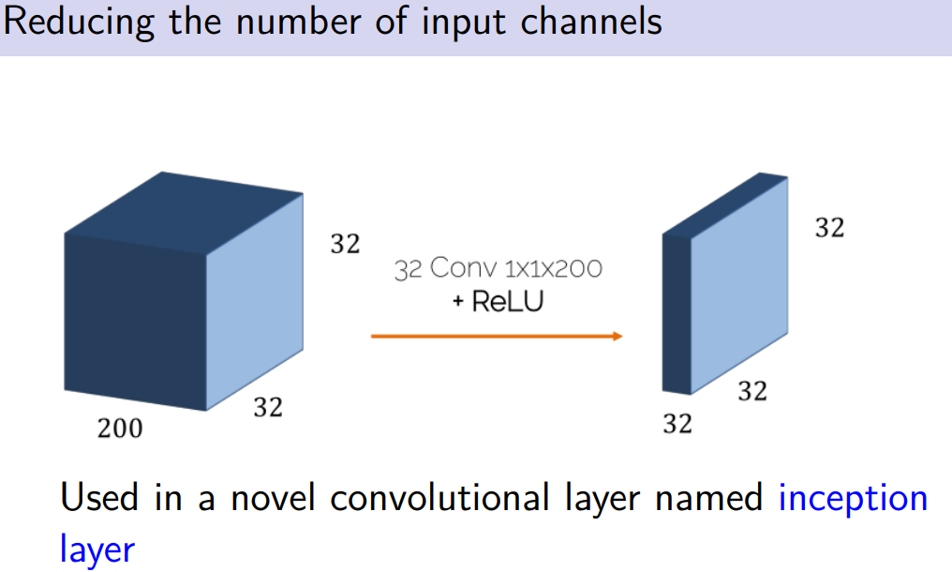
32 filters, one by one convolution

changes the number of outpuc channels. I can get a sort of approximation

inception layer: specific type of convolutional layer that has been proposed by some researcher at google

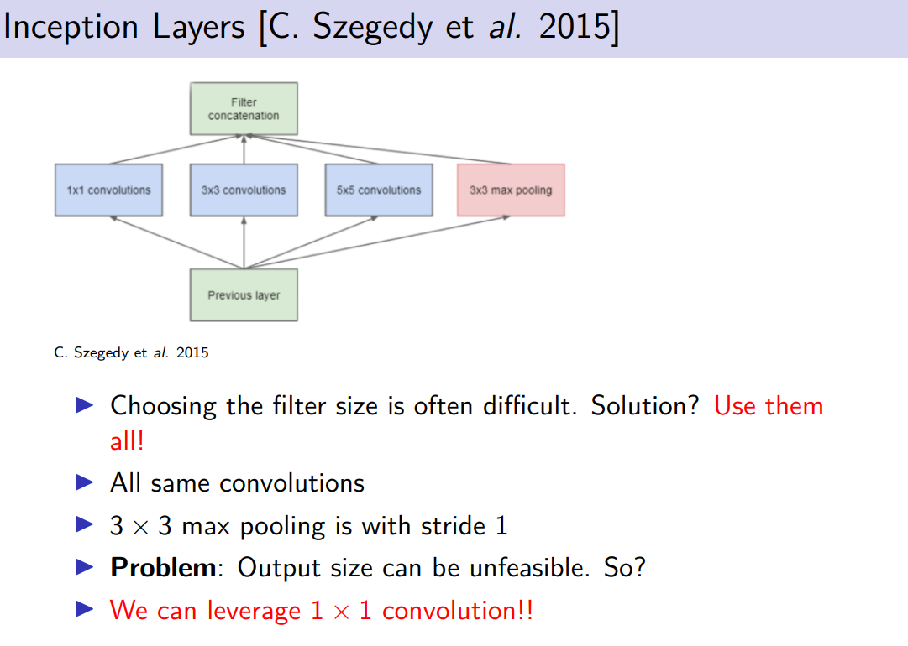
instead of stacking one over eachother the convolution they are parallel on the same level.
Different number of filter.

I can choose different size of filters, getting different scanning of the input and concante the number +compl

using same convioluton you will get same dimension for the feature

problem: can get huge number of parameters, all the channels are concantenated in the filter concatenation. lots of channels, we can leverage the solution

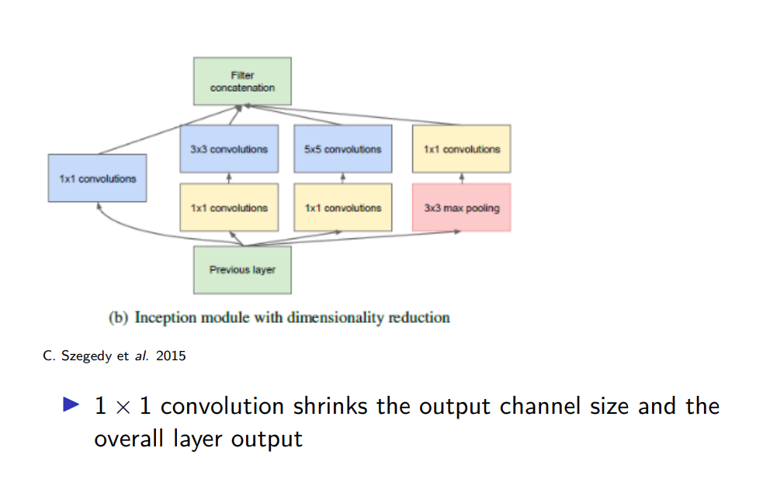
contains 1x1 convuotion to reduce the number the number of channels

after max pooling I still have same numer of channels, apple 1x1 later. The dimension does not exploded

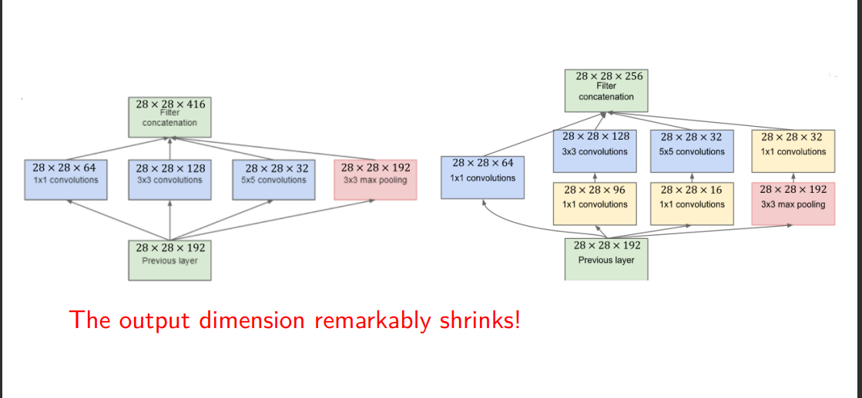

left without convolution 64+128+32 +192 (last 4 elements) we get 416

right use convolutions 1x1.
I can shrink the number of channels.

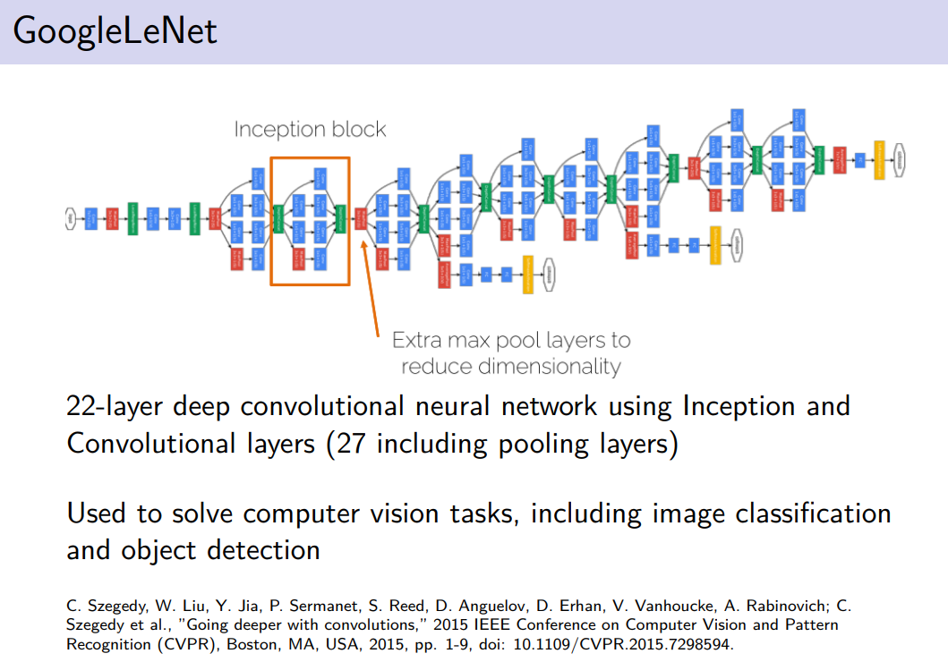

uses the shape of several inception. Sometimes uses maxpooling (red)

